**Lab 01: Pointers and malloc**

Name: **Raja Hasnain Anwar**

Registration: **192135**

Date: **11th Sept, 2017**

**Link:** https://github.com/rhasnainanwar/DSAlab/tree/master/Lab01_pointers_malloc

# Task # 1:

## Code:

#include<iostream>

using namespace std;

int main(void)

{

int *salary = new int[20];

int i;

for (i = 0; i<20; ++i)

{

cout << "Enter Salary: ";

cin >> *(salary + i);

}

for (i = 0; i < 20; ++i){

*(salary + i) = *(salary + i) + *(salary + i) / (i + 1);

cout << *(salary + i) << endl;

}

delete [] salary; //clear memory

return 0;

}

## Output:

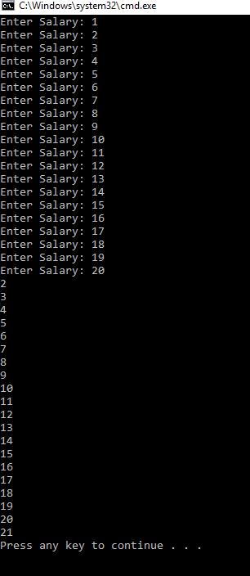

# Task #2:

## Code:

/*

* Kindly fill this information.

* Name: Raja Hasnain Anwar

* Student #: 192135

*/

#include <iostream>

using namespace std;

/*

* PROBLEM #2: Analyze pointers

*/

/*

* PART #1: Write a function that does two things:

* >> Write the memory location pointed by the pointer to the console.

* >> Write the value of the integer (which the pointer points to) to the console.

*/

void analyze_pointer(int *ptr)

{

cout << "Pointer: " << ptr << endl;

cout << "Value: " << *ptr << endl;

}

/*

* PROBLEM #3: Add a couple more functions to the mix

* >> call them int_pointer1 and int_pointer2

* >> both will return int pointers.

*/

/*

* Follow the steps:

* >> the function will allocate an int on the heap (via new int)

* >> assign a value to it

* >> and return that value (an int pointer type).

*/

int* int_pointer1()

{

int *ptr = new int;

*ptr = 425;

return ptr;

}

/*

* Follow the steps:

* >> the function will allocate an int on the stack (via "int iValue;" or something similar)

* >> assign a value to it

* >> and return its memory location (an int pointer type).

*/

int* int_pointer2()

{

int something = 435;

return &something;

}

int main()

{

/*

* PART #2: Use the analyze_pointer function to complete two TASKS

*/

/*

* TASK #1

* >> allocate an int on the stack (e.g., "int iValue;")

* >> assign a value to it

* >> get its memory location (with the reference operator---&)

* >> and pass this value to analyze_pointer.

*/

cout << "Part #2: Memory on stack..." << endl;

// Add your code here!

int iValue; //declared

iValue = 12; //assign

int *ptr = &iValue; //memory location

analyze_pointer(ptr); //pass

/*

* TASK #2

* >> allocate an int on the heap (with the new operator)

* >> assign a value to it

* >> and pass it to analyze_pointer.

*/

cout << "Memory on heap..." << endl;

// Add your code here!

int *new_int; //for heap

new_int = new int; //in heap

*new_int = 65; //assign

analyze_pointer(new_int); //pass

delete new_int; //clear mem

/*

* PROBLEM #3: Call analyze_pointer on the return of functions int_pointer1() and int_pointer2()

*/

cout << "Memory on heap versus on stack..." << endl;

int *temp = int_pointer1();

analyze_pointer(temp);

analyze_pointer(int_pointer2());

/*

* Remember that int was allocated on the heap for function "int_pointer1()"

* Delete it

* and call analyze_pointer on it after deleting it.

*/

cout << "Memory on heap after delete..." << endl;

delete temp;

analyze_pointer(temp);

/*

* Call: analyze_pointer(new int);

*/

// Add your code here!

analyze_pointer(new int);

return 0;

}

## Q/A:

1. In first case, the variable is declared on stack. Then a value is assigned to it. By using &, we pass it’s address to the analyze_pointer() function. There, first the address which is passed is printed, then using dereferencing, the value at that address is printed.  
   In second case, a pointer is declared using new keyword which declares a variable on heap and gives its address. Now we have only the address. Again using dereferencing, the value at the given address is printed.
2. int_pointer1() returns a pointer to a heap memory location. This means, the variable will still be there even after the function exists. For this reason, we are still able to get its value.  
   On contrary, int_pointer2() declares a variable on stack which will vanish from memory when the function exists. For this reason, we get a garbage value for that variable because the required value is no longer on that location.
3. Every time a variable is dynamically declared in heap using new keyword, it is a leak threat. That memory is allocated until freed. Hence, heap variables must be deleted or freed. There are three heap variables but one was deleted as a task hence two memory leaks. Although, I have freed them while doing the task.

## Output:

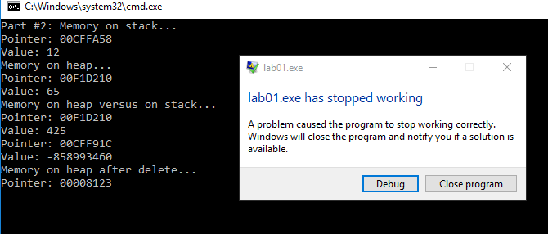

# Task #3:

## Code:

/*

* Kindly fill this information.

* Name:

* Student #:

*/

#include <iostream>

#include <string>

using namespace std;

/*

* Define a struct Area that has two private variable members;

* units of type string and area_value of type float.

*/

class Area

{

private:

string units;

float area_value;

public:

void set_units(string u){

units = u;

}

void set_area(float area){

area_value = area;

}

string get_units(){

return units;

}

float get_area(){

return area_value;

}

};

int main()

{

/*

* Modify program to create a dynamic variable of type Area.

*/

Area *area1 = new Area;

/*

* Input from the keyboard the area_value and its units.

*/

float area_value;

cout << "Enter area value: ";

cin >> area_value;

(*area1).set_area(area_value);

string units;

cout << "Enter Units: ";

cin >> units;

(*area1).set_units(units);

/*

* Compute one-half and one-quarter of the area

* and display the results

*/

cout << (*area1).get_area() / 2.0 << " " << (*area1).get_units() << endl;

cout << (*area1).get_area() / 4.0 << " " << (*area1).get_units() << endl;

/*

* Destroy the dynamic variable at the end

*/

delete area1;

return 0;

}

## Output:

